**Personal Portfolio Analysis (Study Hours)**

In this following short report, you will knowing about the user study hours with the help of dashboard. The following report consists of :

1. User Stories
2. Data Collection & Table Structures
3. Data Model
4. Calculations
5. Exercise Analysis Dashboard

**User Stories**

The business request for this project was created by user himself. By deciding on a business to analyse the following user story was derived.

|  |  |  |  |
| --- | --- | --- | --- |
| **As a (role)** | **I want (request)** | **So that I (user value)** | **Acceptance Criteria** |
| Study enthusiast | I want to track my study hours | To ensure I get enough | A Power BI dashboard which gets me an easy and quick view of my study data |

**Data Collection & Table Structures**

1. **FACT_Activity**

Data was recorded every single date and the focus was on the duration of hours.

The following steps were done in Power BI to transform this table for analysis purpose.

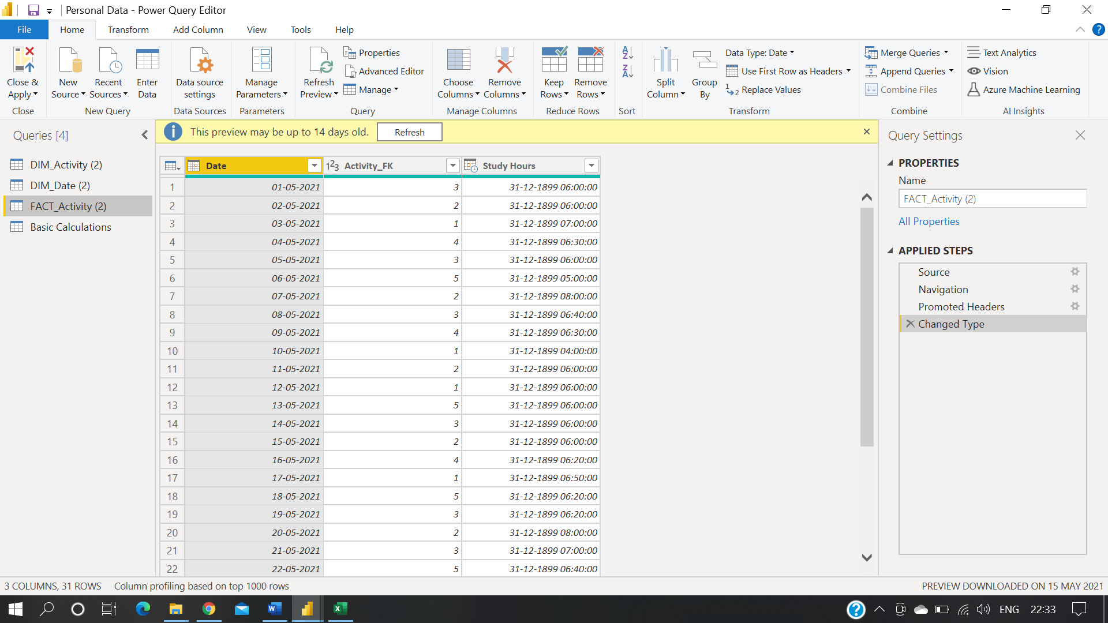

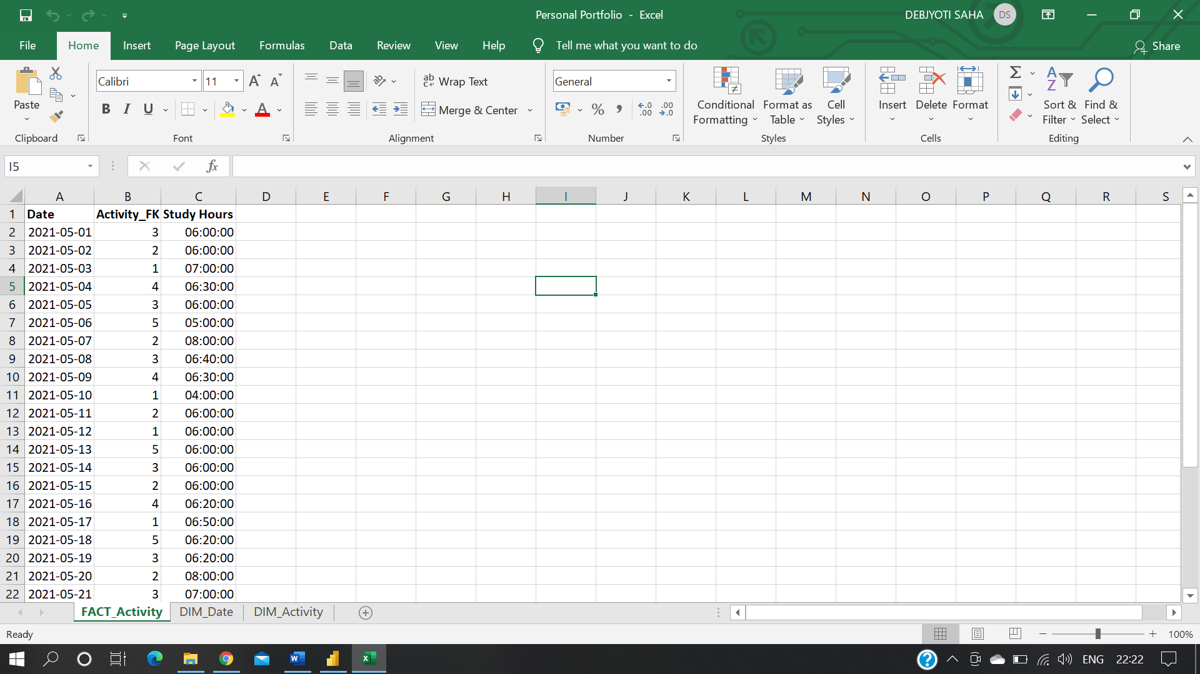

1. **DIM_Activity**

DIM_Activity describes different types of activities.

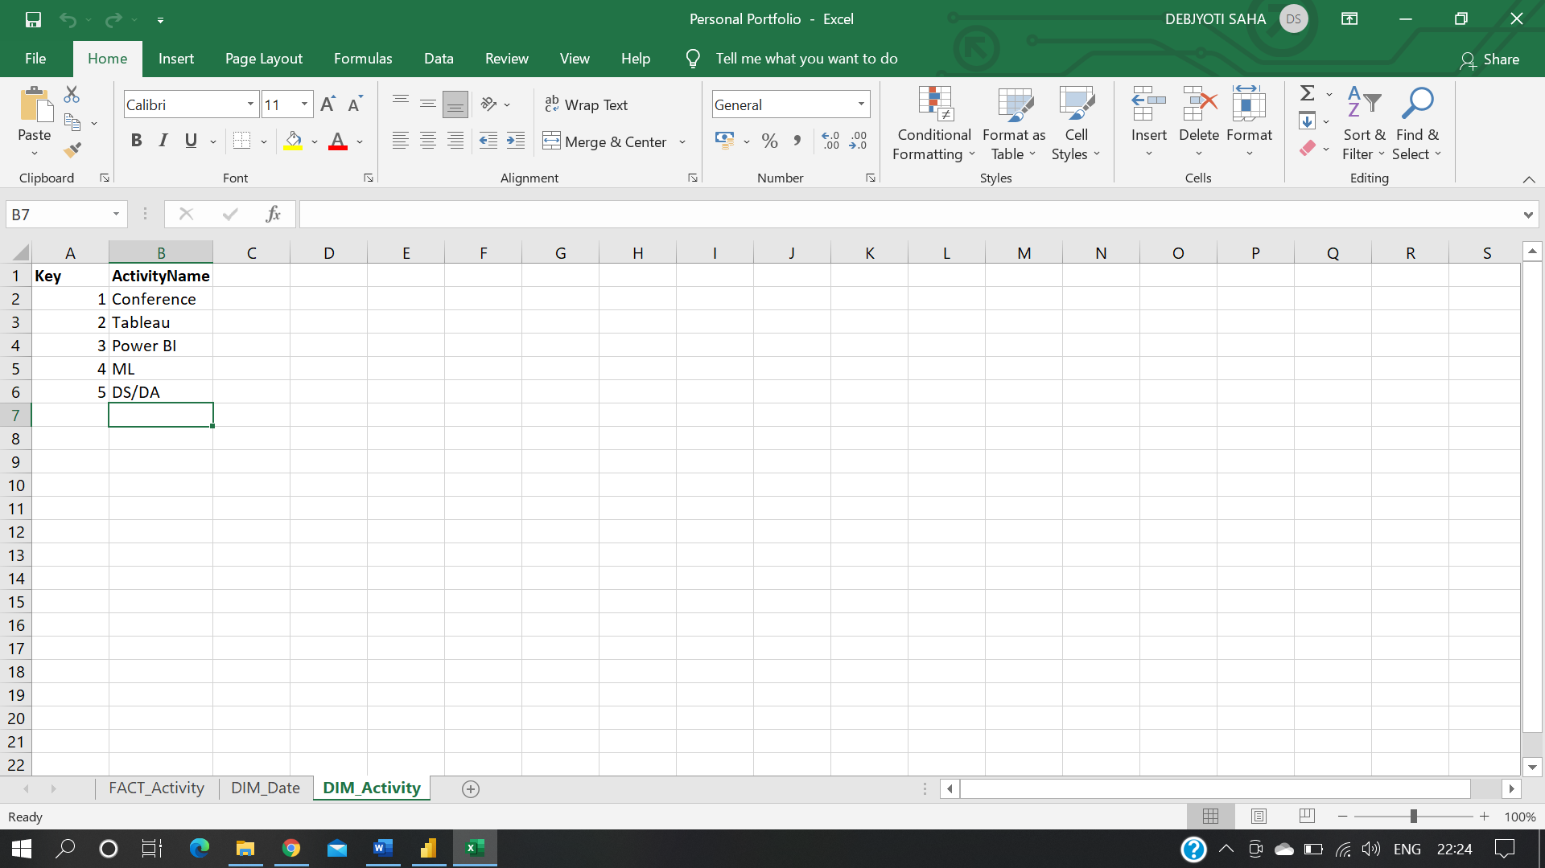 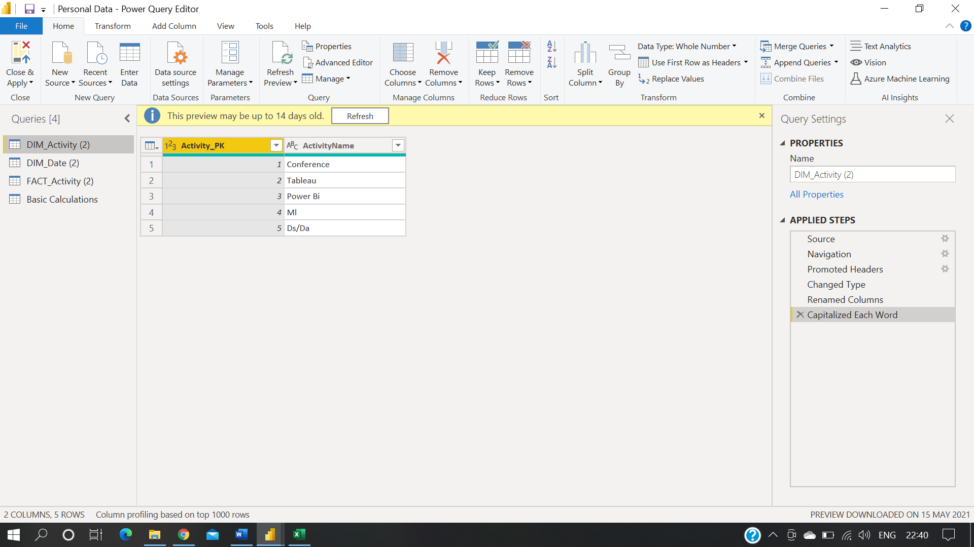

1. **DIM_Date**

DIM_Date dimension is based on a simple table with dates, where dates was used to derive several new fields.

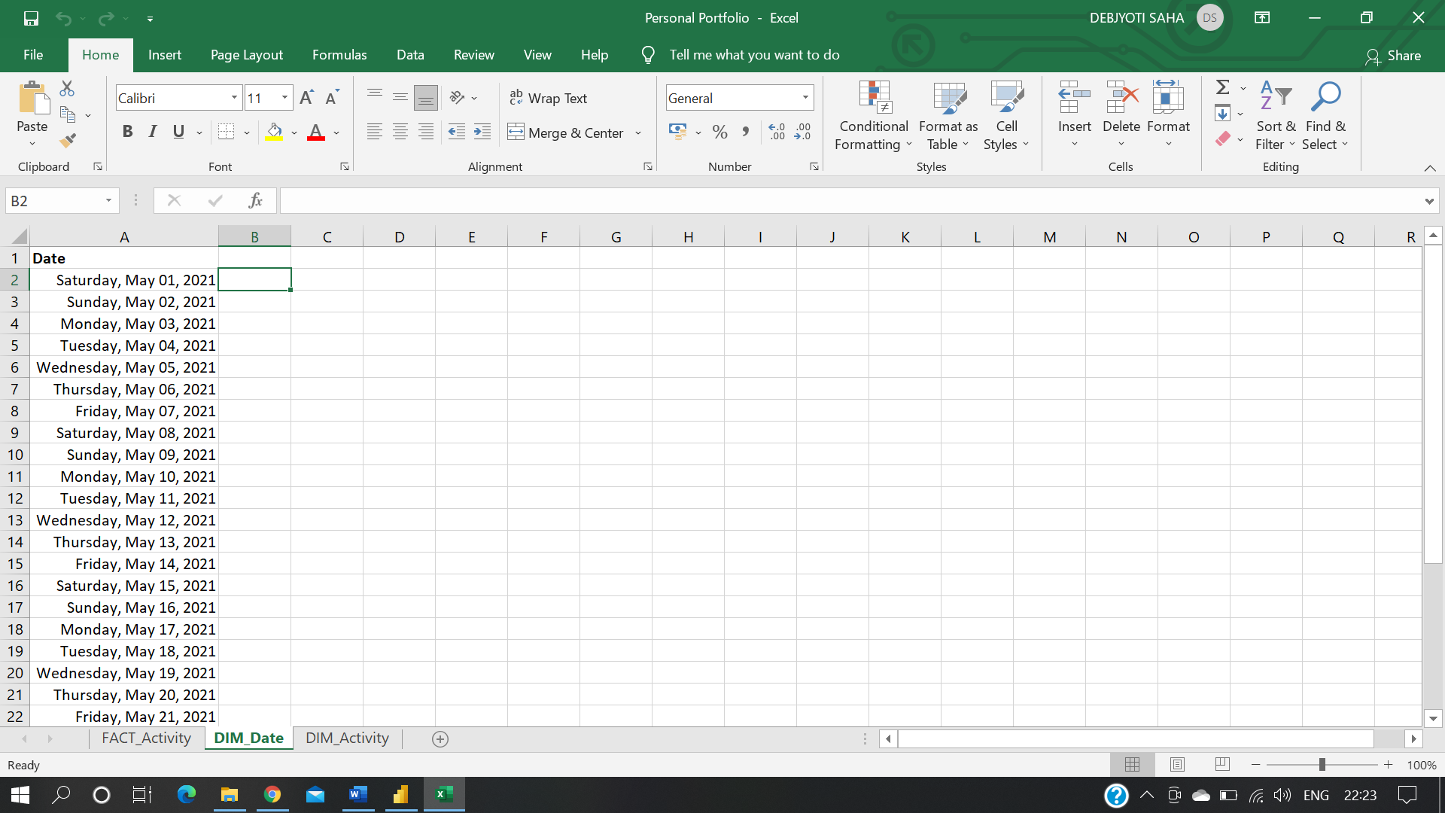 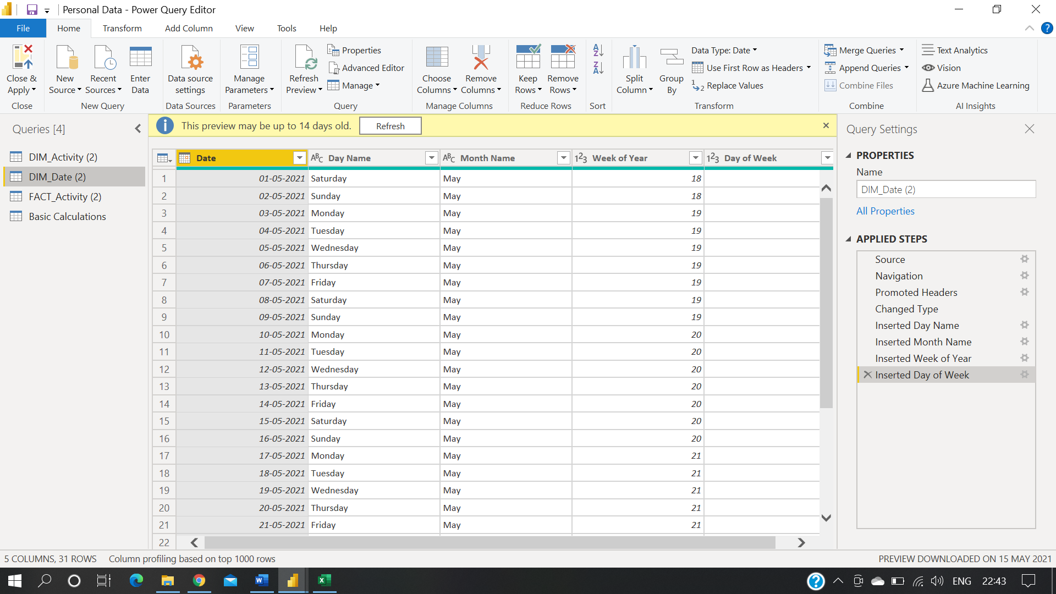

**Data Model**

Below is the screenshot of data model after cleansed and prepared table were read into Power BI.

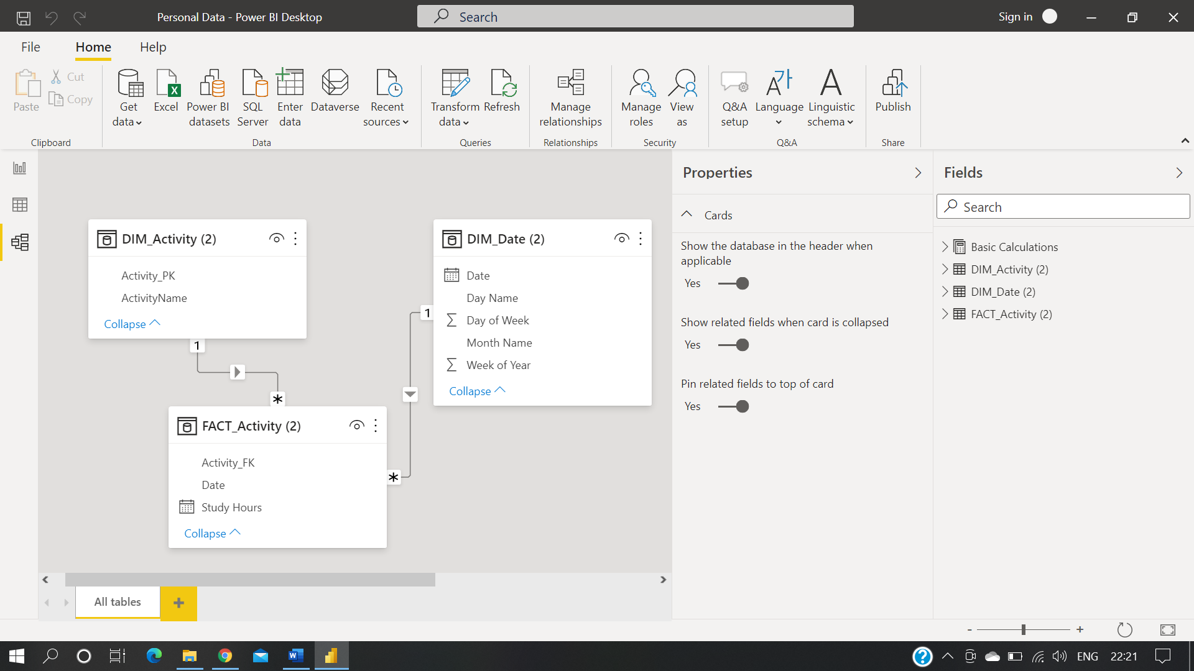

**Calculations**

The following calculations were created using Power BI and DAX. To lessen the extent of coding, the re-use of measures was emphasized:

**Average Hours-** Average Hour = AVERAGEX('FACT_Activity (2)', [Total Steps])

**Exercise Analysis Dashboard**

The finish report consists of one dashboard. The one is basic version, contains DAX and visualisation calculations.

